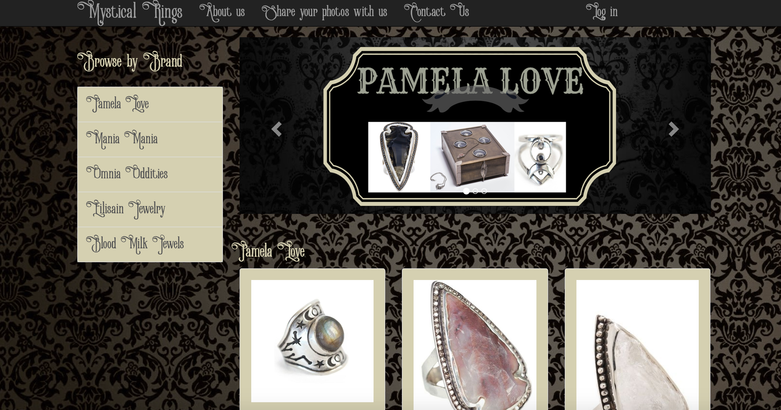

REPORT

## Advanced Web Technologies

Phoebe Kalatzi | Web Design & Development | October 26 2016

Table of Contents

1. **Introduction**…………………………..………………………………………………….……...
2. **Design Section**…………………………….…………………………………………………....13
3. **Enhancements**………………………………………………………….………………....13
4. **Critical Evaluation**……………………………………………………………………....13
5. **Personal Evaluation**…………………………………………………………………....13

**6.** **Summary of Resources and References**…….………………....13

**1. Introduction**

The ‘Mystical Rings’ web application is a collection of beautiful, bizarre and unique rings. It hosts ring collections created by incredibly talented and world-renowned designers such as Pamela Love, Mania Mania, Blood Milk Jewels etc. It is a portal for ring lovers who want to discover one-of-a kind pieces that reflect their controversial and unique personalities and thus it gives them the opportunity to browse, view and discover several ring designs, carefully selected and organised.

Apart from their ability to view several ring collections, users can also interact with the web application by uploading their own personal photos, wearing unique jewellery pieces that they want to share with other unique and alternative people with similar tastes. The only requirement for this feature is that users need to be logged in into the application as super users using their individual authenticated credentials. Normal visitors cannot upload any images, however they are still able to view the users photo collection.

Another interactive facility this web application provides, is the ‘Contact Us’ page where users can complete a form with their personal details and submit their feedback to the website and help its moderators to improve existing areas or build new features. It needs to be said that the current version of this application is a prototype thus it lacks the necessary functionality that saves and maintains the user details and feedback, however the application has been built to mimic this behaviour. As a result after the user submission, a personalised message is auto-generated and displayed to the user

**2. Design Section**

Screen for the main Layout

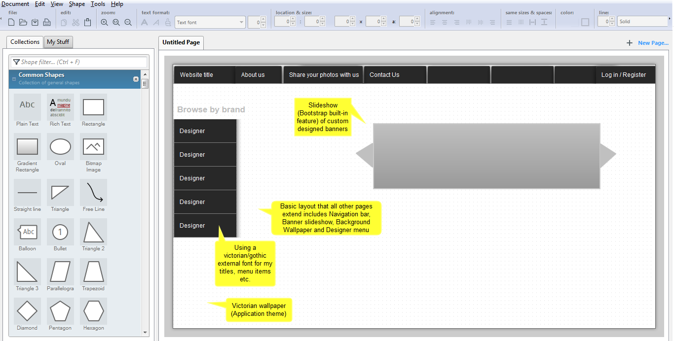

I decided for the main layout to include the top menu bar as well as the left designer categories menu so that the users would be able to navigate to a different page anytime through the application. Another thing I included in the main layout was the Log in/Logout buttons so that users would be always aware of their current status. The main layout also includes the background wallpaper, the main styling configurations as well as the carousel bootstrap built-in feature, which was added for cosmetic purposes.

Screen for the About Us page

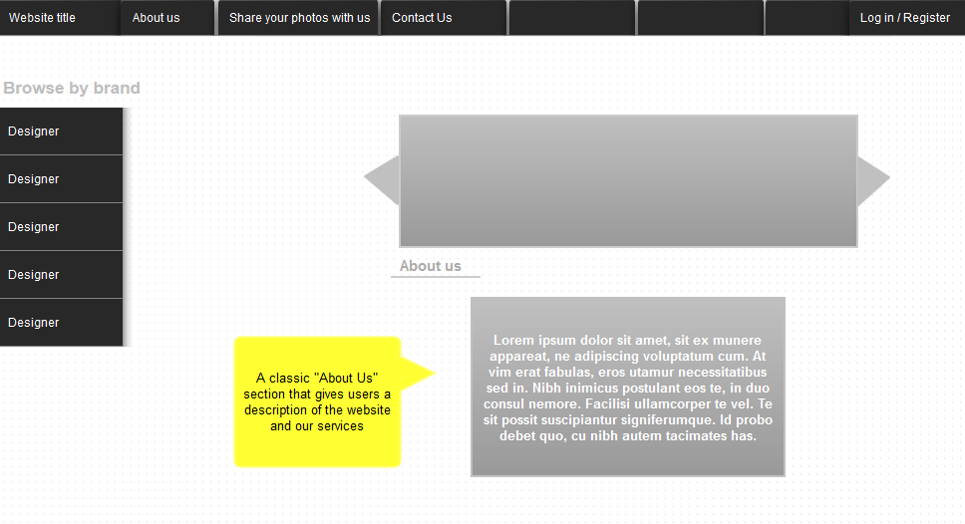

The ‘About Us’ page extends the application’s main layout and it additionally provides a welcoming Introduction for the visitors along with some basic instructions for using all aspects of the application.

Screen for the 404 Error page

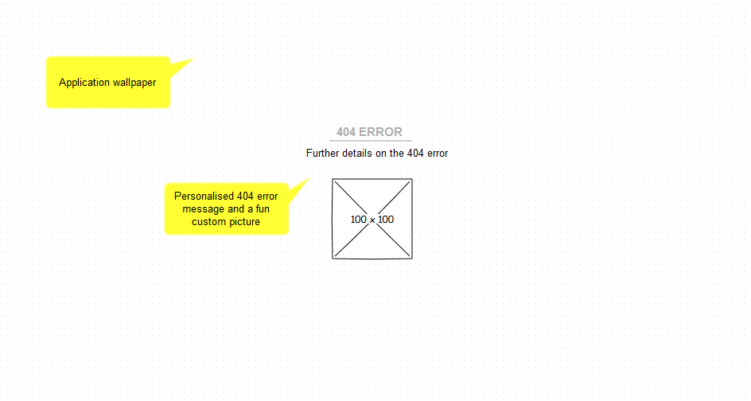

I decided to create a personalized ‘404 error’ page for my application, as it is a very fun and user-friendly feature. I used the application’s background wallpaper, a personalized error message as well as a custom designed error image.

Screen for the Collections page

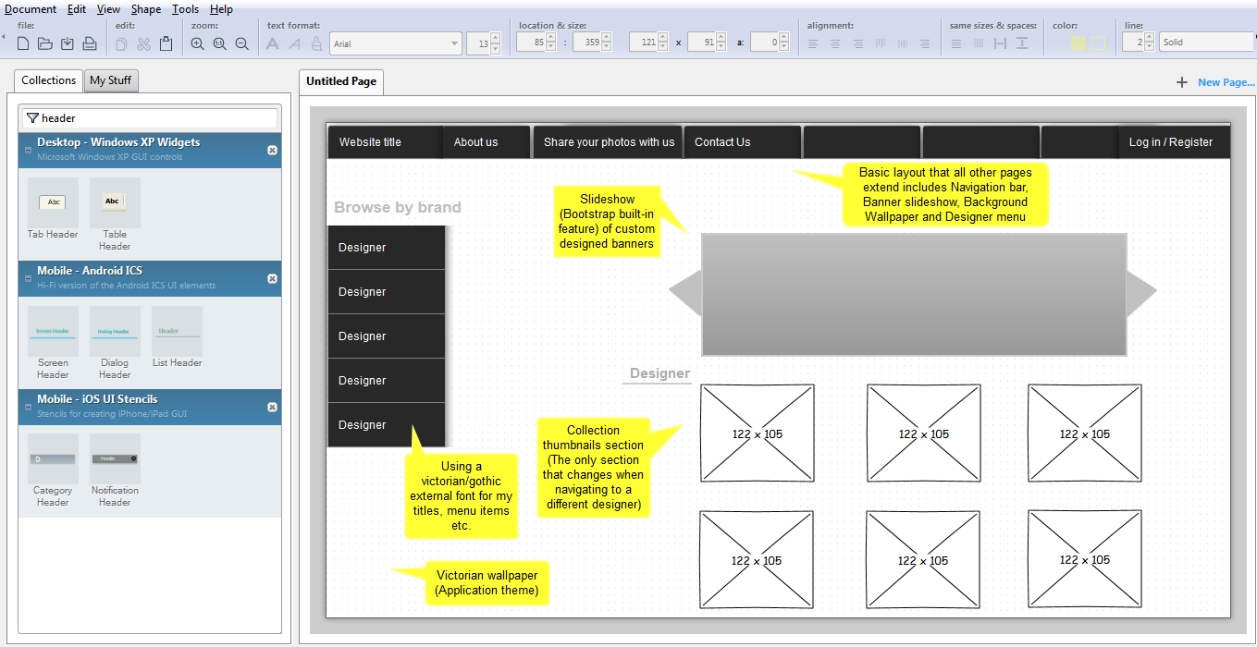The Collections page is the same for all designer categories. It extends the layout template with all the necessary menus and the only part that gets refreshed after navigating to a different designer is the photo collection section that displays different images, titles and descriptions.

Screen for the Photo Upload Service page

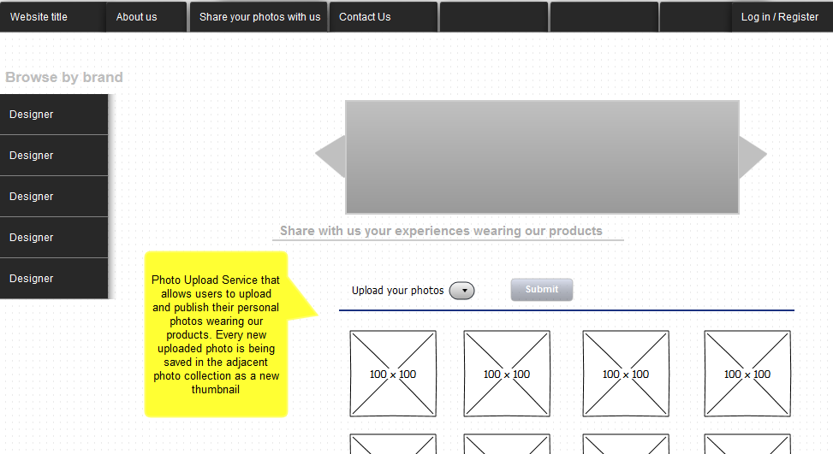

This page extends the main layout template, includes a photo collection of user-uploaded images similarly to the Collections page but additionally provides a file upload feature. After the configuration of the Log in facility a few changes were implemented that are not described in the above design. The above screen is only accessed by logged-in users. Normal visitors cannot view the upload form, instead they can see a notification that informs them about their role limitations and prompts them to login. They can also view normally the user photo gallery.

Screen for the Contact Us page

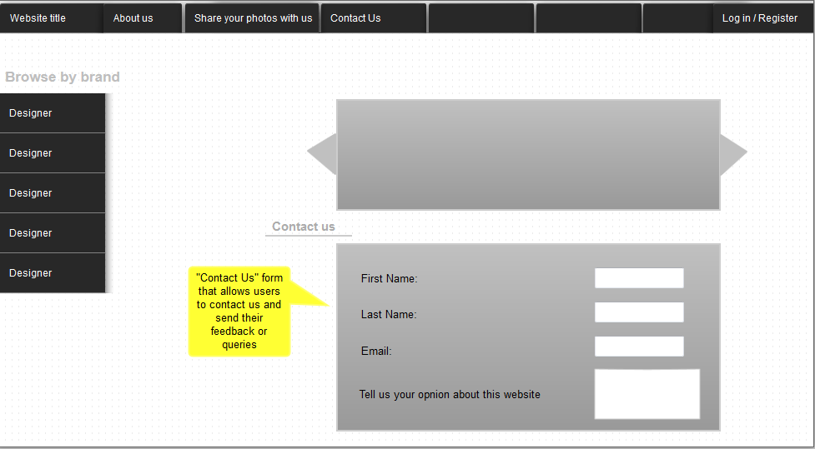

This screen also extends the main layout template and it provides users a form they can fill in with their personal details, feedback messages or simply queries they might have for the system moderators. This way, users can actively engage by sending their requests. After they submit their form, a personalized message flashes back to them to confirm that they were successfully submitted.

There were three other screens I decided to include in the application, that were not initially planned and they all handle the login functionality. The main login screen extends the main layout template and provides a login form that users can fill in with their authenticated credentials to log in into the application. The two other screens also extend the main layout but they only display a message that notifies the user whether they have successfully logged in or logged out from the application.

**3. Enhancements**

The ‘Mystical Rings’ web application is currently mostly a prototype that offers the user some basic features such the ability to browse ring collections, upload their own personal photos or experience different view access rights based on their authentication level. There are several enhancements that could be integrated into the existing application to make it more interactive but for the time being they were out of this coursework’s scope. Some of these additions and improvements include the following:

* **Extra Admin features**: Currently there is only one registered role within this application, which is the super user. The addition of the admin role would be very beneficial since admins could perform administrative tasks, monitor the website’s health and maintain data integrity. Other examples of admin tasks could include, granting access roles to users, process feedback forms and other requests and approving or denying user photo uploads.
* **Ability of users to register**: Currently, users can only log in as super-users under specified credentials that are hardcoded into the code. It would be a nice enhancement to provide them the ability to register a new account, which could be authorised by the admin user as mentioned above.
* **More services to registered/logged-in users**: Currently the only advantage logged in users have against normal visitors of the web application, is their ability to upload their own personal photos. It would be a nice addition if they had also the ability to bookmark their favourite collection items, create their own personal lists and be able to view their last viewed records the next time they would visit and log in into the application.
* **Data being stored in a database:** Currently, due to the lack of a database connection and the storage limits of the browser’s cookies, only small amounts of data can be saved and stored in the web application, such as the user access level that is being stored in a session and only for a short amount of time. Collection items that are displayed in the application are hardcoded into the code and user feedback submissions are not saved after submit, both of which are bad practice examples. As a result, a very useful enhancement that would improve dramatically the user experience would be the use of an external database to store and maintain data including internal data records as well as external ones after they have been submitted to our application.
* **Search Bar**: Adding a search bar into the application would be a major optimisation action for the enhancement of the user experience. Search bars are of the most popular features of the modern websites and it is one of the first things that visitors look for in a website to discover fast and easy records they are interested in.
* **Filtering results, Sorting facility, Additional Categories**: At the moment, rings are only organised by designer. An enhancement in this area would be the addition of more categories for browsing rings such as material, price, colour, collection etc. It would be also beneficial to have a sorting feature that would sort rings alphabetically or in another order so that users could find faster what they are looking for.
* **Translation**: A feature that would make this web application more accessible and would attract more visitors, would be a translation service that would allow users to translate the website’s content into their own native language as long as it is supported.
* **Ability to view photos in full size within modal windows:** At the moment, every photo in our collection page has a default size, which does not allow users to view them in full. This limitation is very inconvenient especially if the users are interested in saving them in their local computers. Consequently, it would be very useful to enable modal windows that would be fired up once an image gets clicked and would display each image in its original size.

**4. Critical evaluation**

I believe that this project demonstrates my ability to develop a fully functional Python Flask application that offers the user several ways of interacting and actively engaging with the application.

I have tried to include as many URLs as I found fit for the purpose of this assignment as well as the appropriate redirects , requests, custom responses and error handling mechanisms to achieve a high level of usability and functionality. I have also followed a structured method for organizing my static files and html templates to produce consistent and effective deliverables.

Apart from my focus on the functional part of the application, I have also spent several hours on improving and enhancing the design of my application since an inviting and elegant user interface is what attracts users and helps them decide whether the webpage is worthy of their time. Also, knowing that the design of an application is the area that gets neglected the most by developers, made me realize that I should ensure that my application’s user interface is cosmetically pleasing and equally meticulous as its technical aspect.

To sum up, my main objective for this coursework was not only to include as many Python-Flask features covered in the labs as possible but also to extend the simple examples we were taught, and by connecting the dots to implement more ambitious results. I know that there are several areas my application could be improved in, however in overall I am satisfied with the end result and I am looking forward to integrate more complicated implementations in my next assignment.

**5. Personal evaluation**

**6. Summary of Resources and References**

Online tools and resources:

* Pencil software by Evolus: For the design of my mockup screens
* <https://www.canva.com> for the design of my banners within the carousel feature
* <http://wallpaper.zone/black-victorian-wallpaper> for the wallpaper of the application’s background
* <http://www.fontspace.com/category/victorian> for the application’s font family. Selected font: Victorian Parlor
* <https://startbootstrap.com/template-overviews/shop-homepage/> for the ring collections
* <https://startbootstrap.com/template-overviews/thumbnail-gallery/> for the user uploads collection

Other documentation from online tutorials and forums

* <http://stackoverflow.com/questions/35115773/font-awesome-doesnt-work-in-flask> for the configuration of the external font
* <http://codereview.stackexchange.com/questions/110679/simple-login-system-using-python-flask-and-mysql> for extra help with the login facility
* <https://www.reddit.com/r/learnpython/comments/1smlni/load_images_from_folder_python2flaskclassy/> to fetch all the user image uploads from my uploads directory and display them in the user photo gallery
* <http://flask.pocoo.org/docs/0.11/patterns/fileuploads/> to save uploaded files under their original filenames